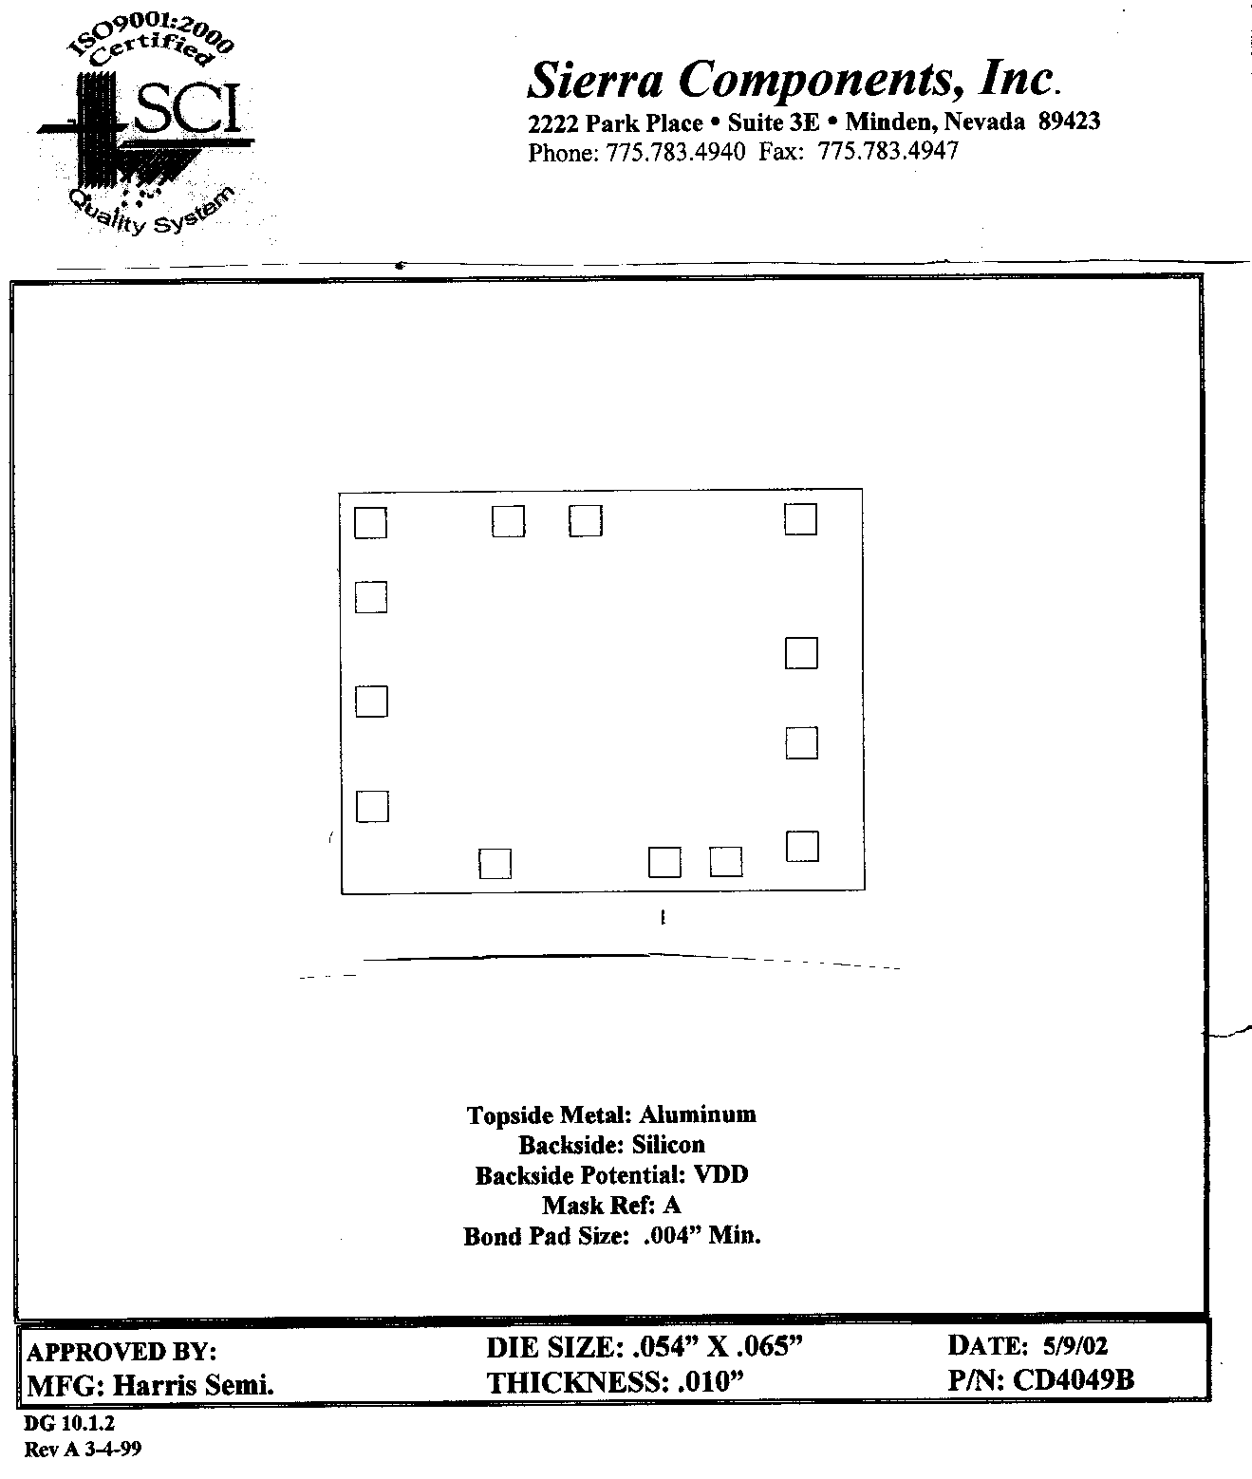
Chip back potential is the level which bulk silicon is maintained by on-chip connection, or it is the level to which the chip back must be connected when specifically stated below. If no potential is given the chip back should be isolated.

PAD FUNCTIONS:

- V_{CC}
- G=N. A
- A
- H=N. B
- B
- I=N. C
- C
- V_{SS}
- D
- J=N. D
- E
- K=N. E
- NC
- F
- L=N. F
- NC

.052”
.064”
14

12

11
3 2 1 15
7 8 9 10
4

5

6
CD40
49UB
MASK
REF

Top Material: Al
Backside Material: Si
Bond Pad Size: .004” X .004”
Backside Potential: V_{CC}
Mask Ref: CD4049UB

APPROVED BY: DK DIE SIZE .052” X .064” DATE: 5/31/23
MFG: TEXAS INSTRUMENTS THICKNESS .011” P/N: CD4049UBH
DG 10.1.2

Rev B, 7/19/02

